Impact and Sustainability of Information Management Systems: Emerging Lessons from the Field

Introduction
People in Need (PIN) has piloted several innovative solutions to respond to challenges in diverse sectors over the years. In recent times, PIN has been supporting public authorities to improve their governance and local resources management by introducing various information management systems (IMS) through its country programs (CP). While some IMS initiatives are only just beginning, the others have been implemented for some time in the CPs. As such, documenting and disseminating emerging lessons from implementing these IMS innovations could provide valuable insights concerning their impact and sustainability.
This learning brief outlines some key lessons learned gathered from several interviews with focal persons (FPs) implementing IMS initiatives in three PIN country programs. This internal document is expected to provide insights on what things to consider when initiating and implementing IMS projects in similar contexts.

Methodology
At first, a rapid review of PIN documents was done to identify potential CPs and focal persons who could be reached out to explore emerging lessons in implementing IMS initiative. Three IMS projects were particularly focused in this instance, which were at various stages of implementation in Cambodia, Ethiopia and Myanmar. Between September and November 2021, a series of online interviews were conducted with pre-identified key focal persons. For one of the IMS projects, an external party involved in handling and managing such IMS platform for PIN was also interviewed. Wherever possible, the assessment reports available on the selected IMS projects were also reviewed in order to enrich the findings.
Below is the list of projects included and people interviewed to draw the lessons learned-
SN | Name/Position | Related IMS | Country
1 | Jak Chowdhary/Project Coordinator-PIN | EWS1294 | Cambodia
2 | Jan Ureš/All for Soil | Participatory Landscape Monitoring through GIS | Ethiopia
3 | Jelínková Klára/Education Advisor-PIN | Education Monitoring Application (EMA) | RDD
4 | Laurel Jansury/Education &Protection Programme Manager | Education Monitoring Application (EMA) | Myanmar

Findings

Overview of the IMS projects
EWS1294 is an innovative Early Warning System developed by PIN in collaboration with National Committee for Disaster Management (NCDM) of the Government of Cambodia. It was first introduced in 2013 and has gone through several development phases ever since. EWS1294 uses Interactive Voice Response (IVR) technology to ensure greater access to vulnerable populations across the country. It contains an innovative monitoring component centered on the production and installation of river gauges. These GSM-enabled devices use sonar sensors to record water surface levels at strategic locations; collected data is subsequently uploaded to an online server, providing important real-time hydrological information to local disaster management authorities, supporting evidence-based decision-making in the process.
As of August 2020, EWS1294 provides full coverage of the territory of Cambodia and is operated by the provincial government, when the need to disseminate an alert to the population emerges. At present, handover of the system to the national government is underway.

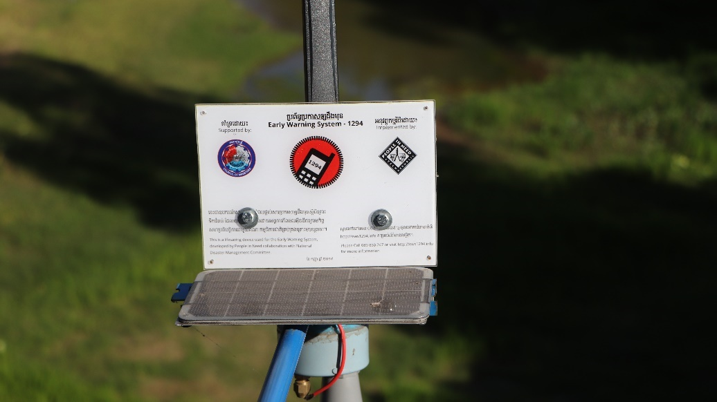

Education Monitoring Application (EMA) first began its pilot implementation in Angola in 2017, with the aim of contributing to improve the quality of education. EMA is used for collection, storage, analyses and visualization of data in the education sector. It has two main components- the mobile app used for collecting data on teachers’ performance, students’ attendance, etc. via phones or tablets (offline) and the Web App where registered users can access the entire database for statistical reports and visualizations of collected data.

At present, EMA version 1 has phased out and EMA version 2 with considerable upgrades is at the pilot stage in some of the PIN CPs such as Angola, Syria, Ethiopia and Myanmar. In all of these CPs, the project is at different stages of implementation. For instance, in Myanmar, the EMA project is at the design phase.
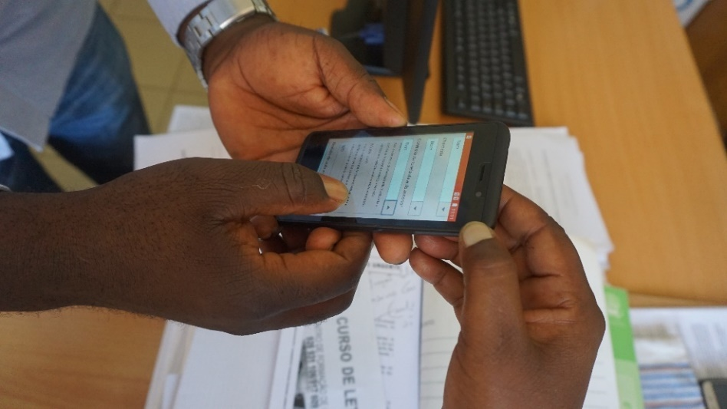

In order to contribute to sustainable management of natural resources and to improve living conditions of farmers in Ethiopia, PIN initiated Participatory Development of Productive Landscape (PDPL) project back in 2017 with funding from Czech Development Agency. In cooperation with All for Soil (AFS), PIN has started extensive digital mapping and detailed collection of GIS data through participatory landscape monitoring. This entails obtaining up-to-date data on soil and water conservation measures in the areas of interest. Based on advanced GIS analyses and remote sensing, the data are recorded in a geodatabase, analyzed and presented in the form of thematic maps. The geodatabase is managed by AFS.
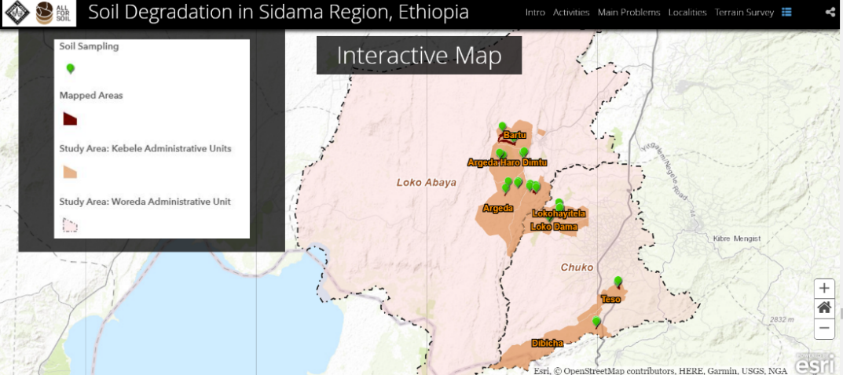
These maps show the location of the measures, their type, their age, the state in which they are and if maintenance is needed. Additionally, any recommended maintenance of specific measures can also be added to the map for thorough planning of further activities.

Key Lessons Learned
All three IMS projects described above are at different stages of implementation. Some intersecting lessons emerging at various stages are discussed below-
- Participatory design and development of the IMS system
One of the key lessons learned by all three IMS projects was the importance of engaging relevant stakeholders from the very beginning through various platforms, such as consultative meetings and need assessments. This could be the local government, the user community, the technology company and so on. Having such a participatory process at all stages; inception, design and development of the IMS project not only ensures ownership, but also facilitates smooth operation and sustainability. EWS1294 in Cambodia, for instance, heavily involved provincial government in the whole process and was able to garner their commitment. Engaging with local stakeholders can help manage the expectations from stakeholders, in terms of funding and technical oversight; and in overall, clarifying on a shared path for the system over a longer-term period. Such participatory design can also help anticipate risks and challenges and better contextualize the IMS.
“Strong foundation with key stakeholders like local government from the very start of the project is extremely important. We have had the relationship with provincial government for almost 10 years, and it is not easy.”
- Project Coordinator, EWS1294

- Mapping technical capacity and resources
Mapping of available resources, assessing capacity of local government, users, implementing partners (if any) and PIN itself should be a part of conceptualization and design. Such assessments will help avoid “over promising” to donors. There could also be challenges of “technical dependency” from the side of local government and partners in such projects. An example of such a dependency is when the local government expects PIN to continue providing IT support to manage the IMS platform citing lack of technical capacity. Addressing and managing the expectations should be part of a long-term capacity development and investment strategy. It is also recommended that, as much as possible, PIN should look for partners which already have the capacity needed for the project. Likewise, having an in-house IMS technical expert within PIN, such as IT officers and engineers, would lessen dependency and ensure much needed flexibility during the operationalization of the IMS project. As was the experience of participatory monitoring in Ethiopia, strategy in case of staff-turnover and prior knowledge of the capacity of end users (like community people or field staffs) should be under considerations. Participatory design and development of the IMS project could be one way to map the local capacity and resources required.
“There was our presumption that the locals knew how to use the map. So, when we provided training, we didn’t include this aspect. But later, we faced technical issues.”
-All for Soil, Participatory landscape monitoring/GIS

- Testing and re-testing the system
Once the IMS is designed, the system must be tested ‘in the field’ from various perspectives, be it something entirely new or something that has been implemented before. The systems which have worked in some contexts may not work in the same way elsewhere. If needed, the system should be modified, appropriately contextualized and re-tested again before launching it at full scale. All interviewed IMS projects in this brief have either piloted or are have plans for piloting. In Myanmar, EMA is at the design stage and they plan to pilot it in the first six months of the operation. EWS1294 started from one province in Cambodia, and now has been able to scale up to cover all its 25 provinces. Allocating sufficient resources and time for testing the system enhances project’s efficiency and impact after dissemination.
- Performance monitoring, assessments, learning and adaptation
Regular and if possible, real-time performance monitoring of the IMS projects is a significant lesson learned from all three projects included in the brief. As much as such monitoring focuses on the technical feasibility, the attention should be to assess to what extent the IMS projects are meeting their objectives and to what degree the relevant stakeholders are satisfied with the results. There should be appropriate accountability and feedback mechanisms, and procedures to ensure that the learning from the field are continuously fed into IMS project improvement.

Conclusion and Way Forward
Designing and implementing an IMS project requires careful considerations beyond its technical feasibility. Rigorous involvement of relevant local stakeholders (including community people and end-users) at all stages, appropriately resourced monitoring and accountability mechanisms and longer-term plan for the capacity development and investment are some of the key lessons being learned by PIN-led IMS projects to ensure their positive impact and sustainability. It is recommended that such lessons learned be continuously documented and disseminated across PIN CPs for improved programming.

Learning brief developed by Devika Rai devika.rai@peopleinneed.cz

EWS1294: Impact and Sustainability Assessment Report 2020
EMA Concept Note, Angola, 2018; EMA Final Project Report, Angola, 2020 ; PINNOVATION EMA, Angola, 2020
StoryMaps of PDPL/NRM project in Sidama region, Ethiopia

